PC-MC BASED WIRELESS COMMUNICATION

Mini Project Report submitted to the Department of Electronics and Communication Engineering in accordance with the academic requirement for the award of the degree.

SUBMITTED BY

SASHANKAR REDDY.S 05B81A0475
K.SAI KIRAN 05B81A0469
P.V.SRIKANTH 05B81A0487



Department of Electronics and Communication Engineering
CVR COLLEGE OF ENGINEERING, JNTU
Vastunagar, Mangalpalli (V), Ibrahimpatan (M), R.R. District

CERTIFICATE

This is to certify that the Mini Project work titled “PC-MC BASED WIRELESS COMMUNICATION” submitted by sashankar reddy s, p.v.srikanth and k.saikiran of ECE, CVR College of Engineering, Vastunagar, Mangalpalli (V), Ibrahimpatan (M), R.R. District, in accordance with the academic requirement for the award of degree Bachelor of Technology in Electronics and Communication Engineering, is a bonafied work carried out by us from May 2008 to June 2008. The project report has not been submitted to any other University or other Institute.

STUDENT HTNO
Sashankar reddy s 05b81a0475
k.saikiran 05b81a0469
p.v.srikanth 05b81a0487

Mr.B.Satish(Asst.Professor) Prof.P.Gurunadha Rao
Project Guide Head of the Department

ACKNOWLEDGEMENTS
The satisfaction that accompanies the successful completion of any tasks would be incomplete without the mention of the people who made it possible and whose encouragement and guidance has been a source of inspiration throughout the course of the project.
We take this opportunity to express our gratitude to all those who helped us to carry out this project successfully. We express our profound gratitude for their valuable guidance and support. We owe our sincere gratitude to our principal Prof. A.D. Rajkumar and also to our college committee members for giving their encouragement that helped us to complete the project successfully.
We are grateful to Mr. B.Satish, our project guide for his constant support and encouragement during the course of the project.
We are thankful to Prof P.Gurunadha Rao, Head of Department, ECE, CVR College of Engineering, for his valuable guidance. We also express our sincere thanks to all the staff members of our college.
Finally, We express our sincere thanks to our parents and friends who supported and encouraged us in many ways for successful completion of the project.

INDEX

1. Introduction 6

2.1Transmitter section 7
2.1.1 Personal computer 7
2.1.2 Micro Controller 8
2.1.3 Power supply 8
2.1.4 Transmitter 9

2.2 Receiver section 10
2.2.1Receiver 10
2.2.2 Micro controller 11
2.2.3 LCD 11

3. Design
3.1Transmitter 12
3.2 Receiver 13
3.3 Power Supply 13
3.4 Microcontroller: AT89C51 15

3.5 RS 232 21
3.6 MAX 232 23
3.7 LCD 24
3.8 RF module 29

4. Design details
4.1Transmitter design 30
4.2Receiver design 30
5. Operational details 30
6. Programming the microcontroller 31
6.1Keil Software 31
6.2 Transmitter code 34
6.3 Receiver code 35
7. Steps involved in the message communication 38
8. Results 38
9. Conclusion and Future 38
10. After Thoughts 39

1.Introduction
Computers and the related technologies are becoming more and more ubiquitous.
Various technical arenas in the field of Computer Science and Engineering, or Information Technology have come very near to the common people. The number of homes with Personal Computers is gradually increasing. A day will come, somewhere in the long future, when PC is referred to in the same class of Food, clothing and shelter". Improvements in the Networking technologies have fostered growth of very dense networks. Land line telephones have been becoming less and less popular and people now prefer communicating while on the move.
A Remote Control is perhaps the most popular gadget today. Right from the intense creativity of remotely controlling laser chip markers to the highly destructive remotely ignitable bombs, from the pins to the planes, remote control is not only occupying a omnipresence state, but is also enhancing its scope and domains.
When people have a good connectivity at their disposal, with tremendous power of mobile computing to supplement the same, we can think of connecting their home appliances to the personal computer or a laptop". With this, people would be able to turn on and off, and to some extent, control the appliances at their home even from a distant place. One of the very basic examples of an utility of this is switching on the air conditioner in the room just some time before reaching home, so that the room is sufficiently cool by then.
The usefulness of a long range remote control to home appliances has no limits.
A trivial setup facilitating such a thing would be to connect the home appliances, to a microcontroller receiver antenna that receives the controls from the user, the means of sending the transmitted signals to the appliances may be via a circuit or through a wireless media like Infra Red or the RF, We have had Infra Red Remote Controls, which work over very short distances, and Radio Wave Remote Controls, which work over larger distances. However, something fundamentally common with all these controls is that the transmitter and receiver should both use some kind of wireless waves.
The project is an implementation to the idea of the wireless communication between a PC and a microcontroller.
The project deals with displaying this possible wireless communication by transferring message from PC to the LCD through wireless media.
We used Microcontroller unit (AT89C51), LCD s {Liquid Crystal Display}, LM7805 Regulator IC, resistors, capacitors, diodes, RF module. To write, test, simulate and debug the code, we used Kiel Complier and the programming was done in C language
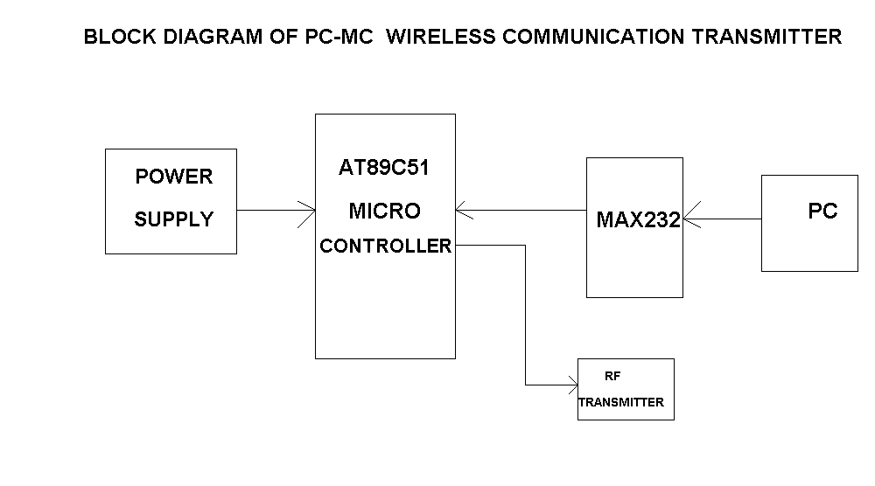
2.1Transmitter section
The transmitter section of the project mainly consists of the following blocks
- Personal computer or laptop
- Micro Controller
- Power supply
- Transmitter

2.1.1Personal computer:
PC is the main element of the communication between the PC and the Micro Controller, PC sends the data to be transmitted to the receiver side device, but the data cannot be transmitted directly from the computer, so it employs a serial communication with the Micro Controller. This requires a Micro Controller to be connected to the PC, so that it is programmed in order to receive data from the computer and transmit the data to the receiver section through the transmitting antenna.
2.1.2Micro Controller:
The micro controller is a programmable device that performs a specific task. In the transmitter section of the arrangement, the microcontroller is used to receive data from the personal computer and the data is transmitted further through the transmitter. The micro controller operates on +5volts that is provided by the power supply.
The communication between the microcontroller and the pc is serial and this is done using the connector ‘RS 232’ that receives the data from the hyper terminal of the pc.
The RS 232 and the microcontroller has a difference in the voltage levels for the binary digits 0 and 1. So we employ MAX 232, a TTL converter between them, so that the data is received by the microcontroller is valid. The TTL converter converts the voltage levels of the RS 232 to match to that of the microcontroller.

2.1.3Power supply:
The microcontroller needs a +5 volts DC voltage supply to operate its internal flip flops and other circuits. The voltage can be supplied from a DC voltage source or through a converter that converts the AC to +5 volts DC voltage.
In order to supply the DC voltage, we employed a Bridge rectifier that converts the AC to DC and the output of the rectifier could not be taken directly due to the fluctuations of the voltage levels of the converted signal, to overcome this, a voltage regulator is employed that converts the pulsated voltage into +5 volts that could be fed to the microcontroller.
The circuit diagram of the power supply is as shown..

+5V POWER SUPPLY
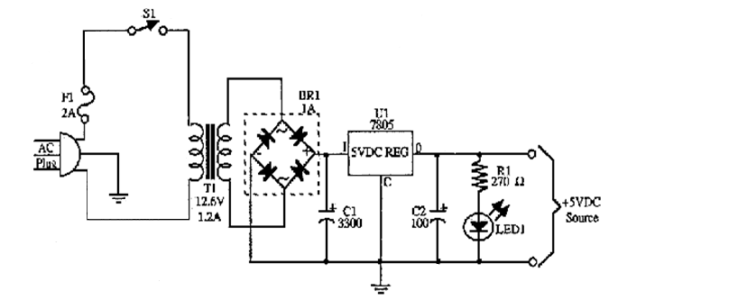

2.1.4Transmitter:
The main objective of the project is to see that the data transmission from one point to other is made possible. This needs a transmitter and a receiver, the transmitter takes the data from the microcontroller and transmits the data to the receiver side where the receiver receives the data. We employ an RF module, which operates at a predetermined RF frequency. The transmitter and the receiver must be synchronized.
The range of the communication of the wireless communication is directly proportional to the size of the antenna employed at the transmitter and receiver sides. The RF transmitter employed also needs a voltage feed of +5 volts to modulate the data received from the microcontroller to avoid the interference of noise and other signals. Depending upon the employed RF module, different type of modulation like OOK (on-off keying), amplitude modulation, or frequency modulation is done.

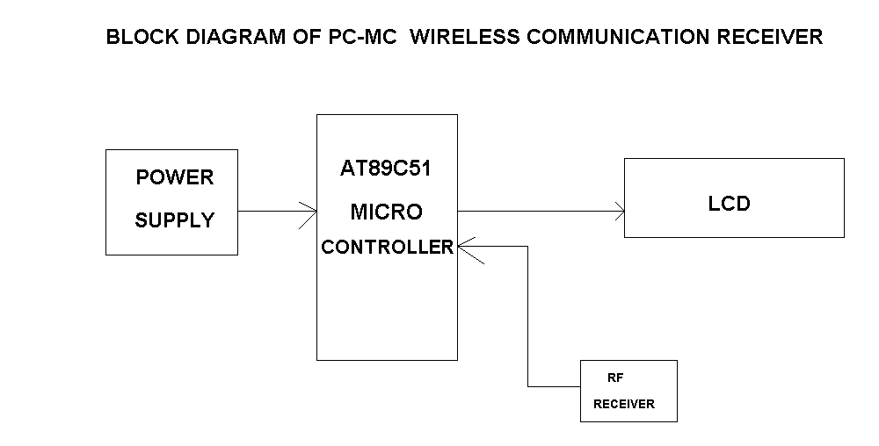
2.2Receiver section
The receiver section of the project mainly consists of the following blocks
- Receiver
- Micro Controller
- Power supply
- LCD

2.2.1Receiver:
In the receiver section, the receivers play a vital role of receiving the data transmitted by the transmitter from the air. This must be very effective in receiving the modulated signal from the transmitter and performing the demodulation on it and sending the data to the microcontroller.
The receiver, similar to that of the transmitter needs a supply feed to demodulate and transfer the data to the microcontroller, this is done by the power supply at the receiver section.

2.2.2Micro controller:
The receiver side microcontroller is programmed in such a way that it receives the data from the receiver and sends back the data to the LCD to display the message. The micro controller controls the data that is sent to the display unit.
The microcontroller needs the power supply of+5 volts similar to that of that at the transmitter side. Hence a power supply device that supplies the required voltage to the microcontroller is employed at the receiver side.

2.2.3LCD:
LCD stands for Liquid Crystal Display. The display takes the commands and data to be displayed on the display screen from the microcontroller. This is an user interface that shows the data typed in at the transmitter side in the hyper terminal of the PC.

PC-MC WIRELESS MESSSAGE COMMUNICATION TRANSMITTER
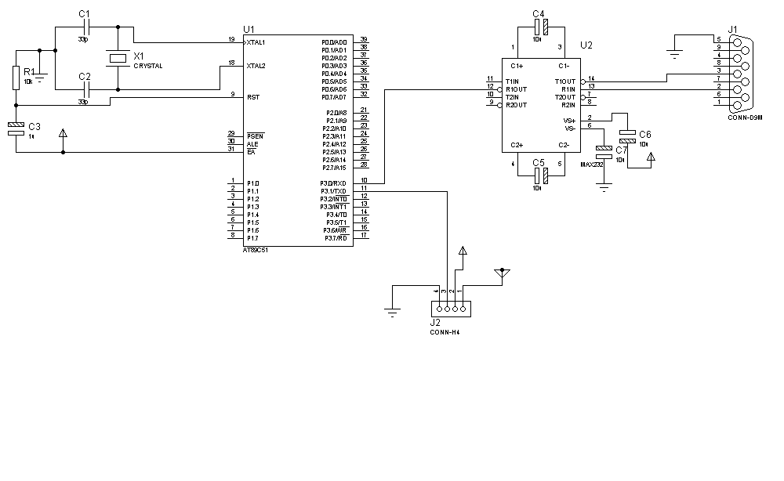
3. Design
3.1Transmitter
In the designing of the transmitter section of the message communication, we employ the following components and equipment.
- Power Supply +5 volts DC.
- RS 232.
- MAX 232.
- Micro Controller AT89C51.
- RF transmitter.

PC-MC WIRELESS MESSSAGE COMMUNICATION RECEIVER
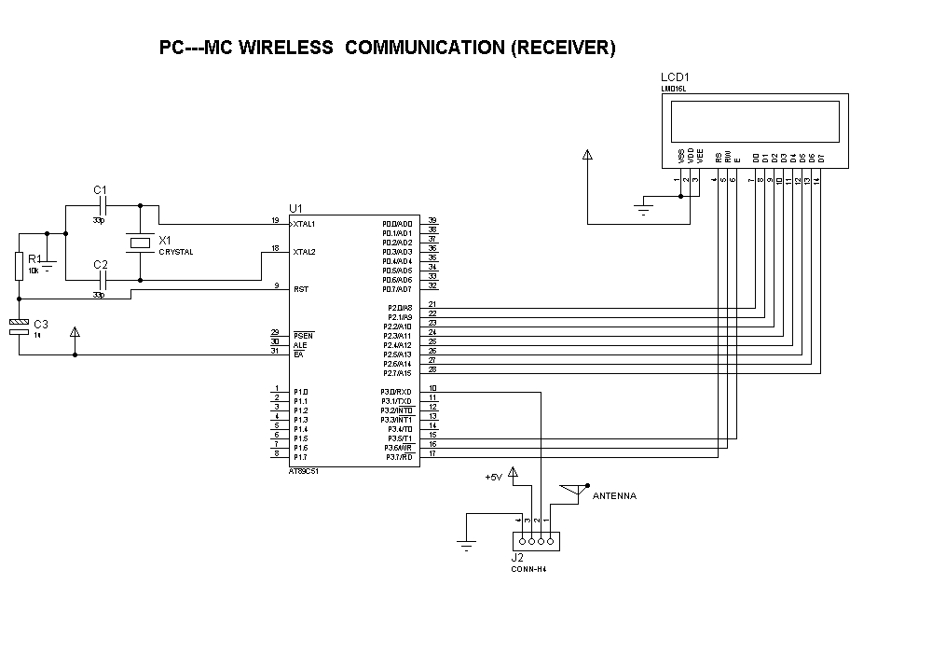

Design details
3.2Receiver
In the designing of the receiver section of the message communication, we employ the following components and equipment.
- Power Supply +5 volts DC.
- RF receiver.
- Micro Controller AT89C51.
- LCD, Hitachi 44780

3.3Power Supply
Most digital logic circuits and processors need a 5 volt power supply. To use these parts we need to build a regulated 5 volt source. The available ac source cannot be directly utilized by the micro controller as a feed. It needs to be converted to +5 volts DC source. The bridge rectifier is used to convert the ac to pulsating dc.
A bridge rectifier makes use of four diodes in a bridge arrangement to achieve full-wave rectification. This is a widely used configuration, both with individual diodes wired as shown and with single component bridges where the diode bridge is wired internally.

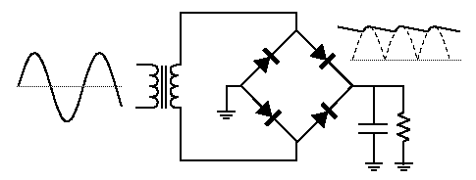
Fig: bridge rectifier with input and output
The pulsating dc is an unregulated power supply ranging from 9 volts to 24 volts DC. To make a 5 volt power supply, we use a LM7805 voltage regulator IC (Integrated Circuit). The IC is shown below.
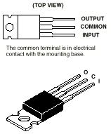
The LM7805 is simple to use. You simply connect the positive lead of your unregulated DC power supply (anything from 9VDC to 24VDC) to the Input pin, connect the negative lead to the Common pin and then when you turn on the power, you get a 5 volt supply from the Output pin.
Sometimes the input supply line may be noisy. To help smooth out this noise and get a better 5 volt output, a capacitor is usually added to the circuit, going between the 5 volt output and ground (GND). We use a 220 uF capacitor

3.4Microcontroller: AT89C51

A micro-controller (also MCU or µC) is a functional computer system-on-a-chip. It contains a processor core, memory, and programmable input/output peripherals.
Microcontrollers include an integrated CPU, memory (a small amount of RAM, program memory, or both) and peripherals capable of input and output. It emphasizes high integration, in contrast to a microprocessor which only contains a CPU (the kind used in a PC).
In addition to the usual arithmetic and logic elements of a general purpose microprocessor, the microcontroller integrates additional elements such as read-write memory for data storage, read-only memory for program storage, Flash memory for permanent data storage, peripherals, and input/output interfaces. At clock speeds of as little as 32 KHz, microcontrollers often operate at very low speed compared to microprocessors, but this is adequate for typical applications. They consume relatively little power (milli watts or even microwatts), and will generally have the ability to retain functionality while waiting for an event such as a button press or interrupt. Power consumption while sleeping (CPU and peripherals off) may be just nano watts, making them ideal for low power and long lasting battery applications.
Microcontrollers are used in automatically controlled products and devices, such as automobile engine control systems, remote controls, office machines, appliances, power tools, and toys. By reducing the size, cost, and power consumption compared to a design using a separate microprocessor, memory, and input/output devices, microcontrollers make it economical to electronically control many more processes.
There are many commercially available microcontrollers in the market. The AT89C51 is a low-power, high-performance CMOS 8-bit microcomputer with 4Kbytes of Flash Programmable and Erasable Read Only Memory (PEROM). The
device is manufactured using Atmel’s high density nonvolatile memory technology
and is compatible with the industry standard MCS-51™ instruction set and pin out. The
on-chip Flash allows the program memory to be reprogrammed in-system or by a conventional nonvolatile memory programmer. By combining a versatile 8-bit CPU with
Flash on a monolithic chip, the Atmel AT89C51 is a powerful microcomputer which
provides a highly flexible and cost effective solution to many embedded control applications.
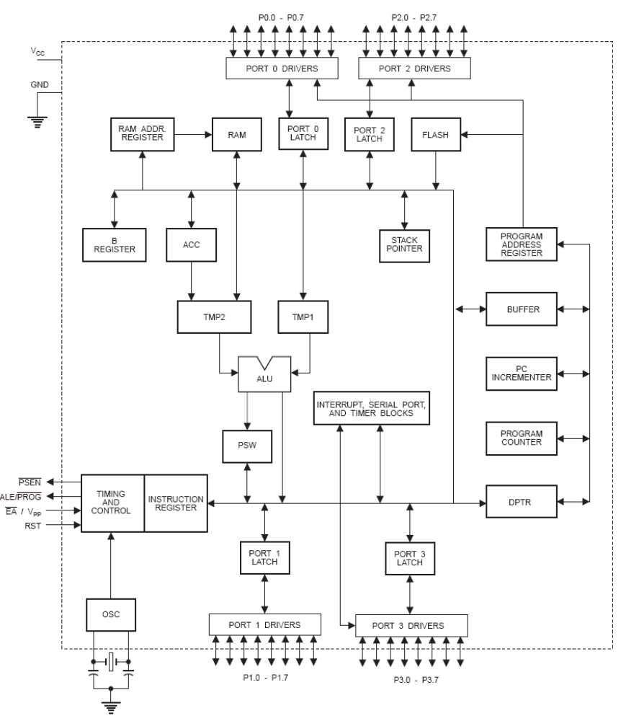

The AT89C51 provides the following standard features: 4Kbytes of Flash, 128 bytes of RAM, 32 I/O lines, two 16-bit timer/counters, a five vector two-level interrupt architecture, a full duplex serial port, on-chip oscillator and clock circuitry. In addition, the AT89C51 is designed with static logic for operation down to zero frequency and supports two software selectable power saving modes. The Idle Mode stops the CPU while allowing the RAM, timer/counters, serial port and interrupt system to continue functioning. The Power Down Mode saves the RAM contents but freezes the oscillator disabling all other chip functions until the next hardware reset.

Pin Description
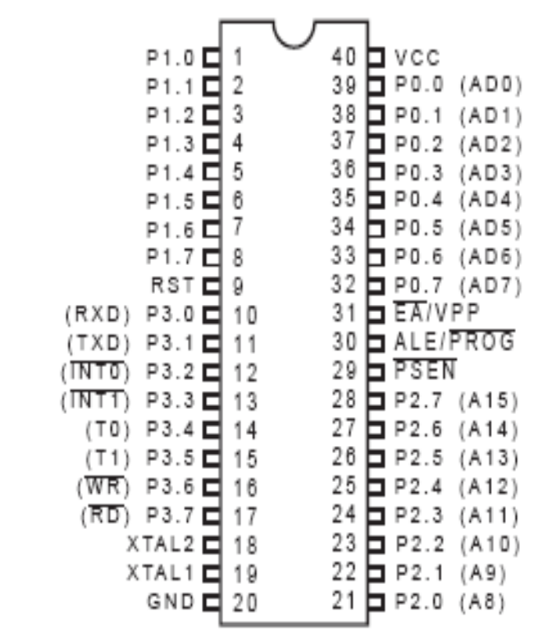

VCC: Supply voltage.
GND: Ground.

Port 0:
Port 0 is an 8-bit open drain bidirectional I/O port. As an output port each pin can sink eight TTL inputs. When 1s are written to port 0 pins, the pins can be used as high impedance inputs. Port 0 may also be configured to be the multiplexed low order address/data bus during accesses to external program and data memory. In this mode P0 has internal pull ups. Port 0 also receives the code bytes during Flash programming, and outputs the code bytes during program verification. External pull ups are required during program verification.

Port 1
Port 1 is an 8-bit bidirectional I/O port with internal pull ups. The Port 1 output buffers can sink/source four TTL inputs. When 1s are written to Port 1 pins they are pulled high by the internal pull ups and can be used as inputs. As inputs, Port 1 pins that are externally being pulled low will source current (IIL) because of the internal pull ups. Port 1 also receives the low-order address bytes during Flash programming and verification.
Port 2
Port 2 is an 8-bit bidirectional I/O port with internal pull ups. The Port 2 output buffers can sink/source four TTL inputs. When 1s are written to Port 2 pins they are pulled high by the internal pull ups and can be used as inputs. As inputs, Port 2 pins that are externally being pulled low will source current (IIL) because of the internal pull ups. Port 2 emits the high-order address byte during fetches from external program memory and during accesses to external data memory that uses 16-bit addresses (MOVX @ DPTR). In this application it uses strong internal pull-ups when emitting 1s. During accesses to external data memory that uses 8-bit addresses (MOVX @ RI), Port 2 emits the contents of the P2 Special Function Register. Port 2 also receives the high order address bits and some control signals during Flash programming and verification.
Port 3
Port 3 is an 8-bit bidirectional I/O port with internal pull ups. The Port 3 output buffers can sink/source four TTL inputs. When 1s are written to Port 3 pins they are pulled high by the internal pull ups and can be used as inputs. As inputs, Port 3 pins that are externally being pulled low will source current (IIL) because of the pull ups. Port 3 also serves the functions of various special features of the AT89C51 as listed below: Port 3 also receives some control signals for Flash programming and verification.
RST
Reset input. A high on this pin for two machine cycles while the oscillator is running resets the device.
ALE/PROG
Address Latch Enable output pulse for latching the low byte of the address during accesses to external memory. This pin is also the program pulse input (PROG) during Flash programming. In normal operation ALE is emitted at a constant rate of 1/6 the oscillator frequency, and may be used for external timing or clocking purposes. Note, however, that one ALE pulse is skipped during each access to external Data Memory. If desired, ALE operation can be disabled by setting bit 0 of SFR location 8EH. With the bit set, ALE is active only during a MOVX or MOVC instruction. Otherwise, the pin is weakly pulled high. Setting the ALE-disable bit has no effect if the microcontroller is in external execution mode.
PSEN
Program Store Enable is the read strobe to external program memory. When the AT89C51 is executing code from external program memory, PSEN is activated twice each machine cycle, except that two PSEN activations are skipped during each access to external data memory.
EA/VPP
External Access Enable. EA must be strapped to GND in order to enable the device to fetch code from external program memory locations starting at 0000H up to FFFFH. Note, however, that if lock bit 1 is programmed, EA will be internally latched on reset. EA should be strapped to VCC for internal program executions. This pin also receives the 12-volt programming enable voltage (VPP) during Flash programming, for parts that require 12-volt VPP.
XTAL1
Input to the inverting oscillator amplifier and input to the internal clock operating circuit.
XTAL2
Output from inverting oscillator amplifier.

Instruction set
The 80C51 instruction set is optimized for 8-bit control applications. It provides a variety of fast addressing modes for accessing the internal RAM to facilitate byte operations on small data structures. The instruction set provides extensive support for one-bit variables as a separate data type, allowing direct bit manipulation in control and logic systems that require Boolean processing.

Program Status Word
The Program Status Word (PSW) contains several status bits that reflect the current state of the CPU. The PSW, resides in the SFR space. It contains the Carry bit, the Auxiliary Carry (for BCD operations), the two register bank select bits, the Overflow flag, a Parity bit, and two user-definable status flags. The Carry bit, other than serving the function of a Carry bit in arithmetic operations, also serves as the “Accumulator” for a number of Boolean operations.
The bits RS0 and RS1 are used to select one of the four register banks. A number of instructions refer to these RAM locations as R0 through R7. The selection of which of the four is being referred to is made on the basis of the RS0 and RS1 at execution time. The Parity bit reflects the number of 1s in the Accumulator: P = 1 if the Accumulator contains an odd number of 1s, and P = 0 if the Accumulator contains an even number of 1s. Thus the number of 1s in the Accumulator plus P is always even. Two bits in the PSW are uncommitted and may be used as general purpose status flags.
Addressing Modes
The addressing modes in the 89C51 instruction set are as follows:
Direct Addressing
In direct addressing the operand is specified by an 8-bit address field in the instruction. Only internal Data RAM and SFR’s can be directly addressed. Philips Semiconductors
Indirect Addressing
In indirect addressing the instruction specifies a register which contains the address of the operand. Both internal and external RAM can be indirectly addressed. The address register for 8-bit addresses can be R0 or R1 of the selected bank, or the Stack Pointer. The address register for 16-bit addresses can only be the 16-bit “data pointer” register, DPTR.
Register Instructions
The register banks, containing registers R0 through R7, can be accessed by certain instructions which carry a 3-bit register specification within the opcode of the instruction. Instructions that access the registers this way are code efficient, since this mode eliminates an address byte. When the instruction is executed, one of the eight registers in the selected bank is accessed. One of four banks is selected at execution time by the two bank select bits in the PSW.
Register-Specific Instructions
Some instructions are specific to a certain register. For example, some instructions always operate on the Accumulator, or Data Pointer, etc., so no address byte is needed to point to it. The op code itself does that. Instructions that refer to the Accumulator as A assemble as accumulator specific op codes.
Immediate Constants
The value of a constant can follow the op code in Program Memory. For example, MOV A, #100 loads the Accumulator with the decimal number 100. The same number could be specified in hex digits as 64H.
Indexed Addressing
Only program Memory can be accessed with indexed addressing, and it can only be read. This addressing mode is intended for reading look-up tables in Program Memory A 16-bit base register (either DPTR or the Program Counter) points to the base of the table, and the Accumulator is set up with the table entry number. The address of the table entry in Program Memory is formed by adding the Accumulator data to the base pointer. Another type of indexed addressing is used in the “case jump” instruction. In this case the destination address of a jump instruction is computed as the sum of the base pointer and the Accumulator data.

3.5 RS 232
Due to it’s relative simplicity and low hardware overhead (as compared to parallel interfacing), serial communications is used extensively within the electronics industry. Today, the most popular serial communications standard in use is certainly the EIA/TIA–232–E specification. This standard, which has been developed by the Electronic Industry Association and the Telecommunications Industry Association (EIA/TIA), is more popularly referred to simply as “RS–232” where “RS” stands for “recommended standard”. In recent years, this suffix has been replaced with “EIA/TIA” to help identify the source of the standard. We use the common notation of “RS–232” in its discussion of the topic.
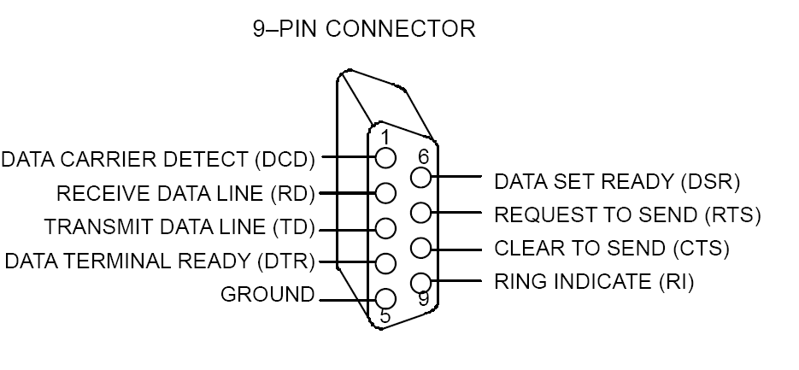
Electrical characteristics
The electrical characteristics section of the RS–232 standard includes specifications on voltage levels, rate of change of signal levels, and line impedance. The original RS–232 standard was defined in 1962. As this was before the days of TTL logic, it should not be surprising that the standard does not use 5 volt and ground logic levels. Instead, a high level for the driver output is defined as being +5 to +15 volts and a low level for the driver output is defined as being between –5 and –15 volts. The receiver logic levels were defined to provide a 2 volt noise margin. As such, a high level for the receiver is defined as +3 to +15 volts and a low level is –3 to –15 volts. Figure 1 illustrates the logic levels defined by the RS–232 standard. It is necessary to note that, for RS–232 communication, a low level (–3 to –15 volts) is defined as a logic 1 and is historically referred to as “marking”. Likewise a high level (+3 to +15 volts) is defined as logic 0 and is referred to as “spacing”. The RS–232 standard also limits the maximum slew rate at the driver output. This limitation was included to help reduce the likelihood of cross–talk between adjacent signals. The slower the rise and fall time, the smaller the chance of cross talk. With this in mind, the maximum slew rate allowed is 30 V/ms. Additionally, a maximum data rate of 20k bits/second has been defined by the standard. Again with the purpose of reducing the chance of cross talk. The impedance of the interface between the driver and receiver has also been defined. The load seen by the driver is specified to be 3kW to 7kW. For the original RS–232 standard, the cable between the driver and the receiver was also specified to be a maximum of 15 meters in length. This part of the standard was changed in revision “D” (EIA/TIA–232–D). Instead of specifying the maximum length of cable, a maximum capacitive load of 2500 pF was specified which is clearly a more adequate specification. The maximum cable length is determined by the capacitance per unit length of the cable which is provided in the cable specifications.

3.6 MAX 232
The MAX220–MAX249 family of line drivers/receivers is intended for all EIA/TIA-232E and V.28/V.24 communications interfaces, particularly applications where ±12V is not available.
These parts are especially useful in battery-powered systems, since their low-power shutdown mode reduces power dissipation to less than 5μW.
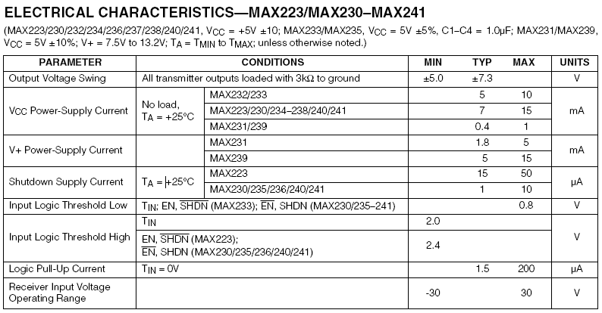
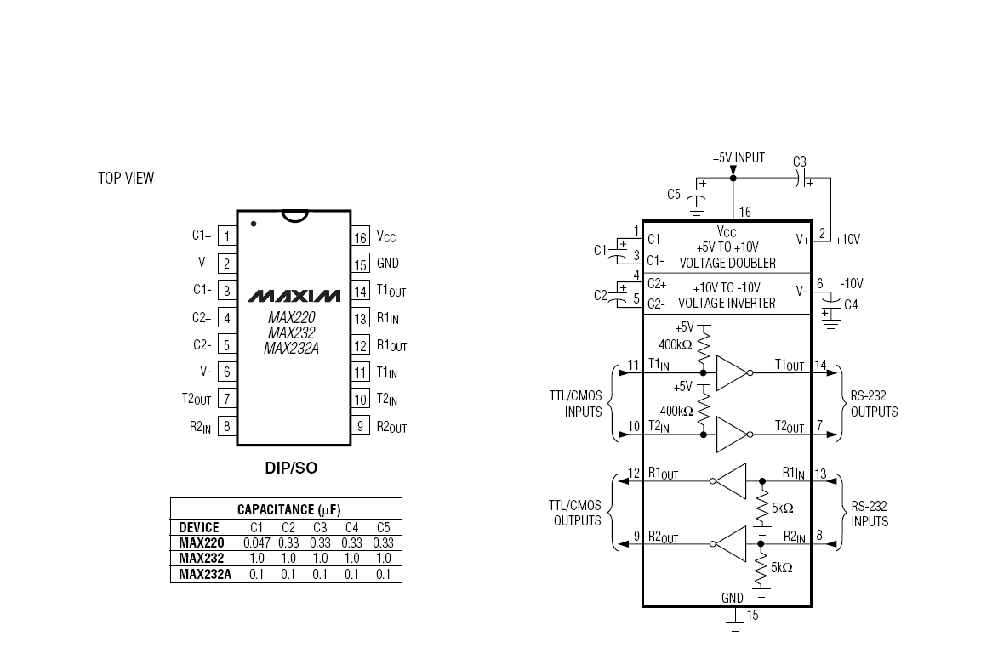

3.7LCD (LIQUID CRYSTAL DISPLAY)
Description:
LCD’s can add a lot to your application in terms of providing an useful interface for the user, debugging an application or just giving it a "professional" look. The most common type of LCD controller is the Hitachi 44780, which provides a relatively simple interface between a processor and an LCD. Using this interface is often not attempted by inexperienced designers and programmers because it is difficult to find good documentation on the interface, initializing the interface can be a problem and the displays themselves are expensive.

PIN DIAGRAM:
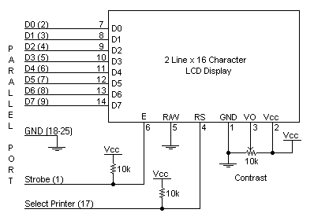

PIN DESCRIPTION:
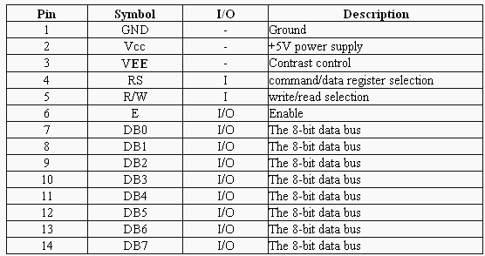
As you would probably guess from this description, the interface is a parallel bus, allowing simple and fast reading/writing of data to and from the LCD.
Above is the quite simple schematic pin diagram. The LCD panel's Enable and Register Select is connected to the Control Port. The Control Port is an open collector / open drain output. While most Parallel Ports have internal pull-up resistors, there are a few which don't. Therefore by incorporating the two 10K external pull up resistors, the circuit is more portable for a wider range of computers, some of which may have no internal pull up resistors.
We make no effort to place the Data bus into reverse direction. Therefore we hard wire the R/W line of the LCD panel, into write mode. This will cause no bus conflicts on the data lines. As a result we cannot read back the LCD's internal Busy Flag, which tells us if the LCD has accepted and finished processing the last instruction. This problem is overcome by inserting known delays into our program.
The 10k Potentiometer controls the contrast of the LCD panel. Nothing fancy here. You can use a bench power supply set to 5v or use a onboard +5 regulator.
The 2 line x 16 character LCD modules are available from a wide range of manufacturers and should all be compatible with the HD44780. The diagram to the right, shows the pin numbers for these devices. When viewed from the front, the left pin is pin 14 and the right pin is pin 1.
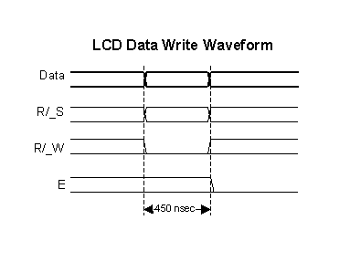
LCDs can be added quite easily to an application and use as few as three digital output pins for control. As for cost, LCDs can be often pulled out of old devices or found in surplus stores for less than a dollar. The most common connector used for the 44780-based LCDs is 14 pins in a row, with pin centers 0.100" apart.

As you would probably guess from this description, the interface is a parallel bus, allowing simple and fast reading/writing of data to and from the LCD.
This waveform will write an ASCII Byte out to the LCD's screen. The ASCII code to be displayed is eight bits long and is sent to the LCD either four or eight bits at a time. If four-bit mode is used, two "nibbles" of data (Sent high four bits and then low four bits with an "E" Clock pulse with each nibble) are sent to make up a full eight-bit transfer. The "E" Clock is used to initiate the data transfer within the LCD.
Sending parallel data, as either four or eight bits are the two primary modes of operation. While there are secondary considerations and modes, deciding how to send the data to the LCD is most critical decision to be made for an LCD interface application.
Eight-bit mode is best used when speed is required in an application and at least ten I/O pins are available. Four-bit mode requires a minimum of six bits. To wire a microcontroller to an LCD in four-bit mode, just the top four bits (DB4-7) are written to. The "R/S" bit is used to select whether data or an instruction is being transferred between the microcontroller and the LCD. If the Bit is set, then the byte at the current LCD "Cursor" Position can be read or written. When the Bit is reset, either an instruction is being sent to the LCD or the execution status of the last instruction is read back (whether or not it has completed).

The different instructions available for use with the 44780 are shown in the table below:
R/S | R/W | D7 | D6 | D5 | D4 | D3 | D2 | D1 | D0 | Instruction/Description
4 | 5 | 14 | 13 | 12 | 11 | 10 | 9 | 8 | 7 | Pins
0 | 0 | 0 | 0 | 0 | 0 | 0 | 0 | 0 | 1 | Clear Display
0 | 0 | 0 | 0 | 0 | 0 | 0 | 0 | 1 | * | Return Cursor and LCD to Home Position
0 | 0 | 0 | 0 | 0 | 0 | 0 | 1 | ID | S | Set Cursor Move Direction
0 | 0 | 0 | 0 | 0 | 0 | 1 | D | C | B | Enable Display/Cursor
0 | 0 | 0 | 0 | 0 | 1 | SC | RL | * | * | Move Cursor/Shift Display
0 | 0 | 0 | 0 | 1 | DL | N | F | * | * | Set Interface Length
0 | 0 | 0 | 1 | A | A | A | A | A | A | Move Cursor into CGRAM
0 | 0 | 1 | A | A | A | A | A | A | A | Move Cursor to Display
0 | 1 | BF | * | * | * | * | * | * | * | Poll the "Busy Flag"
1 | 0 | D | D | D | D | D | D | D | D | Write a Character to the Display at the Current Cursor Position
1 | 1 | D | D | D | D | D | D | D | D | Read the Character on the Display at the Current Cursor Position

"*" - Not Used/ Ignored. This bit can be either "1" or "0"
Before you can send commands or data to the LCD module, the Module must be initialized. For eight-bit mode, this is done using the following series of operations:
- Wait more than 15 msecs after power is applied.
- Write 0x030 to LCD and wait 5 msecs for the instruction to complete
- Write 0x030 to LCD and wait 160 μsecs for instruction to complete
- Write 0x030 AGAIN to LCD and wait 160 μsecs or Poll the Busy Flag
- Set the Operating Characteristics of the LCD
  - Write "Set Interface Length"
  - Write 0x010 to turn off the Display
  - Write 0x001 to Clear the Display
  - Write "Set Cursor Move Direction" Setting Cursor Behavior Bits
  - Write "Enable Display/Cursor" & enable Display and Optional Cursor
Once the initialization is complete, the LCD can be written to with data or instructions as required. Each character to display is written like the control bytes, except that the "R/S" line is set. During initialization, by setting the "S/C" bit during the "Move Cursor/Shift Display" command, after each character is sent to the LCD, the cursor built into the LCD will increment to the next position (either right or left). Normally, the "S/C" bit is set
(equal to "1") along with the "R/L" bit in the "Move Cursor/Shift Display" command for characters to be written from left to right (as with a "Teletype" video display).
The "Ninth Character" is the position of the Ninth character on the first line.
Most LCD displays have a 44780 and support chip to control the operation of the LCD. The 44780 is responsible for the external interface and provides sufficient control lines for sixteen characters on the LCD. The support chip enhances the I/O of the 44780 to support up to 128 characters on an LCD. From the table above, it should be noted that the first two entries ("8x1", "16x1") only have the 44780 and not the support chip. This is why the ninth character in the 16x1 does not "appear" at address 8 and shows up at the address that is common for a two line LCD.
3.8 RF module
The TWS-434 and RWS-434 are extremely small, and are excellent for applications requiring short-range RF remote controls. The transmitter module is only 1/3 the size of a standard postage stamp, and can easily be placed inside a small plastic enclosure.
TWS-434: The transmitter output is up to 8mW at 433.92MHz with a range of approximately 400 foot (open area) outdoors. Indoors, the range is approximately 200 foot, and will go through most walls.....
The TWS-434 transmitter accepts both linear and digital inputs, and can operate from 1.5 to 12 Volts-DC, and makes building a miniature hand-held RF transmitter very easy. The TWS-434 is approximately the size of a standard postage stamp.
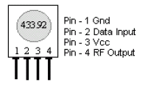
Transmitter, TWS-434 Pin Diagram
The receiver also operates at 433.92MHz, and has a sensitivity of 3uV. The RWS-434 receiver operates from 4.5 to 5.5 volts-DC, and has both linear and digital outputs.
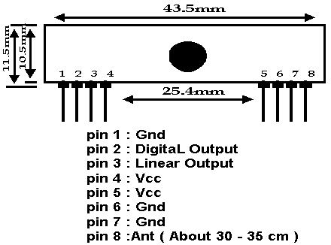
Receiver, RWS-434 Pin Diagram

4. Design details
4.1Transmitter design
The PC is connected to the microcontroller through the RS 232 which in turn is connected to the TTL converter, MAX 232 for the voltage matching of the RS 232 and microcontroller. A crystal oscillator is connected to control the timing of the operations as performed by the microprocessor.
The pins connections between the cable and the voltage converter are for the transfer and acknowledgement of data between RS232 and MAX 232. The MAX 232 output pin, (R1OUT) is connected to the receiver pin (RXD) of the microcontroller. The transmitter pin (TXD) of the microcontroller is connected to the data input pin of the RF transmitter.
The power requirements are achieved by using the power supply of +5 volts generated from the ac voltage using the bridge rectifier and the voltage regulator together. This is fed to the voltage converter, microcontroller and to the RF transmitter at the transmitting end. All the ground terminals are tied together to 0 volts.

4.2Receiver design
The design of the receiver is comparatively less complex to that at the transmitter side. The receiver antenna connected at the receiving end is connected to the microcontroller through the data receive pin RXD. The data is retransmitted to the display unit through one of the output ports, Port 2 to the data pins of the display unit. Controls of the display are connected to read, write and timer 0 of the micro controller as shown in the figure. Similar to that at the transmitter side, the power supply is fed to the devices at the receiver side.
5. Operational details
At the transmitter side,
The data entered in the hyper terminal of the PC is converted into its equivalent ASCII code, and as the communication between the PC and the microcontroller is serial communication. The data is sent serially through the connector with a start and a stop bit added to the actual data. The data is sent to the microcontroller bit by bit serially through the TXD pin. The microcontroller has serial interrupts, receive interrupt (RI) and transmit interrupt (TI) to show that data is received or transmitted. This data is stored in the buffer register of the microcontroller and later transmitted through the RXD pin to the RF transmitter that modulates and transmits the data.

At the receiver side,
The data as received by the RF receiver is directed towards the micro controller, which stores the data in the buffer register, as the data communication is serial, after the reception of the 8 bit data, the data is sent to the display unit through the output port, Port2 of the micro controller. The controlling of the display and data flow is done by the microcontroller which is programmed to do so. The ASCII code received by the display unit is decoded and the alphabet is displayed on the screen.

6. Programming the microcontroller

The microcontroller is a programmable device with certain specifications and design rules. The microcontroller used in developing the project is AT89C51. It contains a programmable flash memory, into which the program code could be dumped. The code can be written in assembly language or in C language and then convert it to a hex file after compiling it and then be written on the flash ROM of the microcontroller.
To write, test, simulate and debug the code, we used Kiel Complier and the programming was done in C language.

6.1Keil Software
An assembler is a software tool designed to simplify the task of writing computer programs. It translates symbolic code into executable object code. This object code may then be programmed into a microcontroller and executed. Assembly
language programs translate directly into CPU instructions which instruct the processor what operations to perform. Therefore, to effectively write assembly programs, you should be familiar with both the microcomputer architecture and the assembly language.
Assembly language operation codes (mnemonics) are easily remembered. You can also symbolically express addresses and values referenced in the operand field of instructions. Since you assign these names, you can make them as meaningful as the mnemonics for the instructions. For example, if your program must manipulate a date as data, you can assign it the symbolic name DATE. If your program
contains a set of instructions used as a timing loop (a set of instructions executed repeatedly until a specific amount of time has passed), you can name the instruction group TIMER_LOOP.
An assembly program has three constituent parts:
- Machine instructions
- Assembler directives
- Assembler controls
A machine instruction is a machine code that can be executed by the machine. Detailed discussion of the machine instructions can be found in the hardware manuals of the 8051 or derivative microcontroller.
Assembler directives are used to define the program structure and symbols, and generate non-executable code (data, messages, etc.). Assembler directives instruct the assembler how to process subsequent assembly language instructions. Directives also provide a way for you to define program constants and reserve space for variables.
Assembler controls set the assembly modes and direct the assembly flow. Assembler controls direct the operation of the assembler when generating a listing file or object file. Typically, controls do not impact the code that is generated by the assembler. Controls can be specified on the command line or within an assembler source file.
The Ax51 assembler has several directives that permit you to define symbol values, reserve and initialize storage, and control the placement of your code. The directives should not be confused with instructions. They do not produce executable code, and with the exception of the DB, DW and DD directives, they have no direct effect on the contents of code memory. These directives change the state of the assembler, define user symbols, and add information to the object file.
Several new variants of the 8051 extend the code and/or xdata space of the classic 8051 with address extension registers. The following table shows the memory classes used for programming the extended 8051 devices. These memory classes are available for classic 8051 devices when you are using memory banking with the LX51 linker/locater. In addition to the code banking known from the BL51 linker/locater, the LX51 linker/locator supports also data banking for Xdata and code areas with standard 8051 devices.
The memory prefixes D: I: X: C: B0: .. B31: cannot be used at Ax51 assembler level. The memory prefix is only listed for better understanding. The Lx51 linker/locater and several Debugging tools, for example the µVision2 Debugger, are using memory prefixes to identify the memory class of the
address. If you are using the Dallas 390 contiguous mode the address space for CODE can be C:0000 - C:0xFFFFFF.
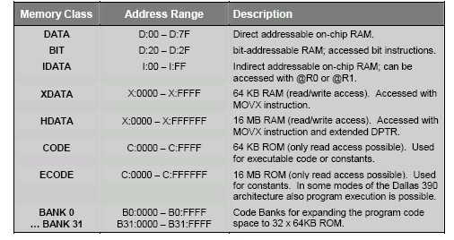
Each line of an assembly program can contain only one control, directive, or instruction statement. Statements must be contained in exactly one line. Multi– line statements are not allowed. Statements in x51 assembly programs are not column sensitive. Controls, directives, and instructions may start in any column. Indentation used in the programs in this project is done for program clarity and is neither required nor expected by the assembler. The only exception is that arguments and instruction operands must be separated from controls, directives, and instructions by at least one space.
All x51 assembly programs must include the END directive. This directive signals to the assembler that this is the end of the assembly program. Any instructions, directives, or controls found after the END directive are ignored. The shortest valid assembly program contains only an END directive.
6.2TRANSMITTER CODE
#include<reg51.h>
#include<intrins.h>
sbit sw1=P1^1;

void main()
{

while(1)
{

TMOD=0x20;
TH1=0xFD;
TR1=1;
SCON=0x50;
TI=0;
RI=0;
while(RI!=1);
P2=SBUF;
SBUF=P2;
RI=0;
}

}

6.3RECEIVER CODE
#include<reg51.h>
#include<intrins.h>

#define lcd_port P2

/*lcd pins*/
sbit rs=P3^7;
sbit rw=P3^6;
sbit en=P3^5;

unsigned char z,y;

void delay()
{
for(z=0;z<10;z++)
{
for(y=0;y<100;y++)
{
_nop_();
}
}
}

void lcd_cmd(unsigned char cmd)
{
lcd_port=cmd;
rs=0;
en=1;
delay();
en=0;
}
void lcd_intial()
{
lcd_cmd(0X80);
lcd_cmd(0X38);
lcd_cmd(0X06);
lcd_cmd(0X0C);
lcd_cmd(0X01);
}
void lcd_data(unsigned char dt)
{
lcd_port=dt;
rs=1;
en=1;
delay();
en=0;
}

void serial()
{
TMOD=0x20;
TH1=0xA0;
TR1=1;
SCON=0x50;
}

void main()
{
unsigned char a[17]="waiting.........";
unsigned char i,ch,j=15;;
serial();
P2=0x00;
rw=0;
lcd_intial();
TI=0;
RI=0;
for(i=0;i<17;i++)
{
lcd_data(a[i]);
}
while(1)
{

RI=0;
TI=0;
while(RI!=1);
if(j==16)
{
lcd_cmd(0x01);
j=0;
}
j++;
lcd_cmd(0x06);
P1=SBUF;
SBUF=P1;
ch=P1;
RI=0;
lcd_data(ch);
}
}
7. Steps involved in the message communication
- Connect the cable, RS 232 to the microcontroller through MAX 232.
- Switch on the power supply.
- Open the hyper terminal.
  - →Start→All programs→Accessories→Communication→Hyper terminal
- Establish a new connection and fix the baud rate to a predetermined value. This connected the microcontroller to the pc.
- Data is typed in the hyper terminal that is to be transmitted and displayed.
- The data reception and transmission controls are programmed into the microcontroller.
- The transmitter transmits the data.
- The receiver receives the data and sends it to the receiving side micro controller.
- The microcontroller saves and forwards the ASCII code to the display unit.
- The display unit displays the data on the screen.

8. Results
The purpose of the project is achieved. The main objective of displaying characters on the display unit is practically tested and achieved. The data typed in the hyper terminal is transmitted and displayed on the display screen. The data is overwritten once the 16 bits are displayed. We tested these modules using a 14", solid, 24 gauge hobby type wire, and reached a range of over 400 foot. Your results may vary depending on your surroundings. The range can be improved by employing antenna of greater length.

9. Conclusion and Future
Scope
In this report, we described PC-MC based wireless communication as a project that helps us talk to devices that are connected to a remote computer. A careful implementation of the idea suggested by the project can prove to be very beneficial in promoting home automation and similar activities. This project can be considered as a proof of concept, {the concept that it is possible to mobilize the control of appliances). By employing various coding techniques this can be produce security.

10. After Thoughts
If we were to do this project again, we would probably consider finding a pair of transceivers that operates on different frequencies. This would simplify the logic and avail communication from simplex to full duplex from one end to another.
We would also change it so that it can communicate with more than one other device. This should not be too difficult, since all we have to do is to include the target device's identification number when we are about to send a message. That way, only the target device will pick up the transmission.
We would employ a coding technique uniquely decoded by the target device. This makes the communication secure.

